**クロスワード**

よこ

１．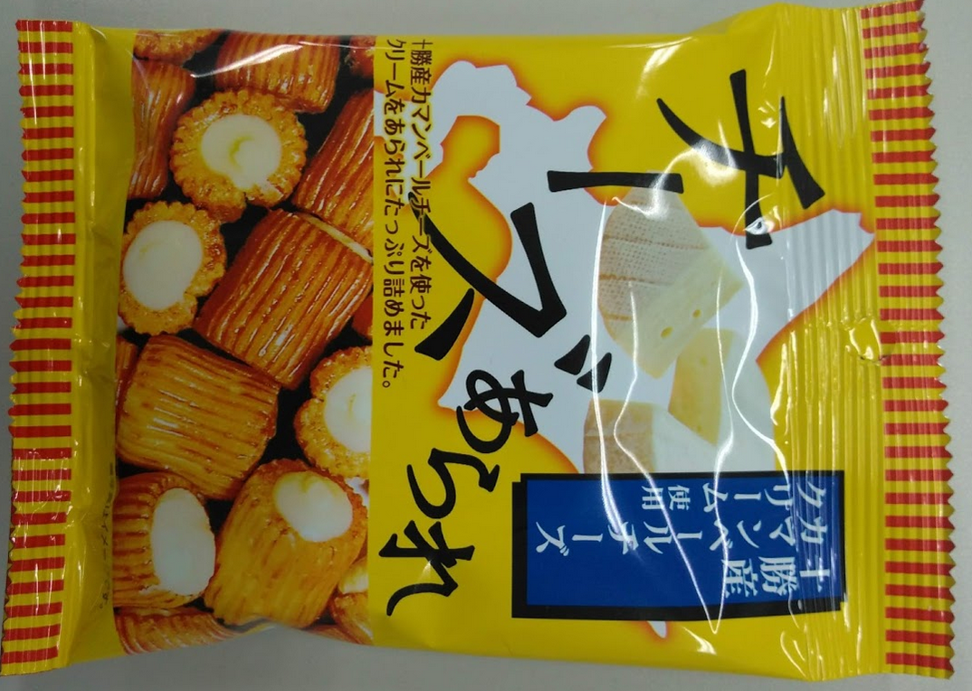2．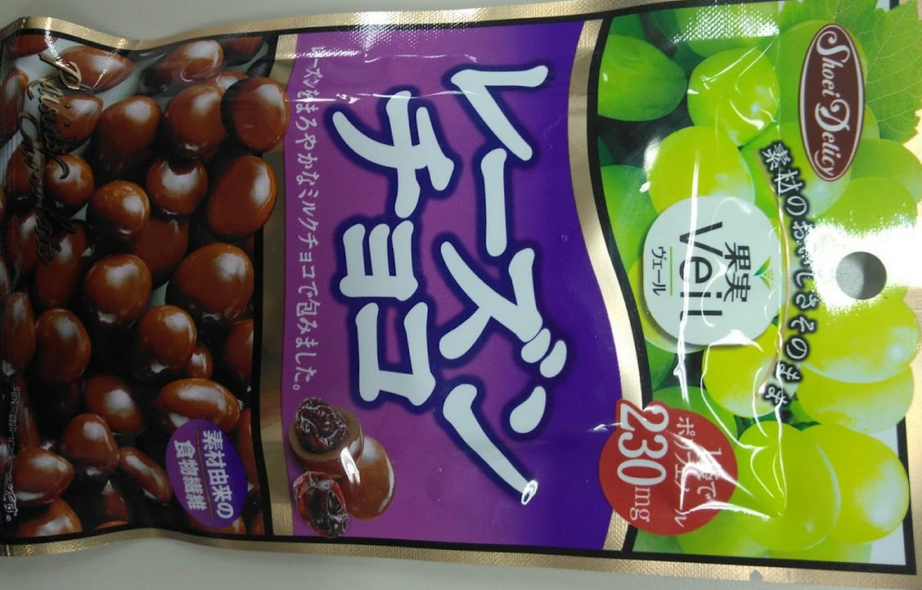

　3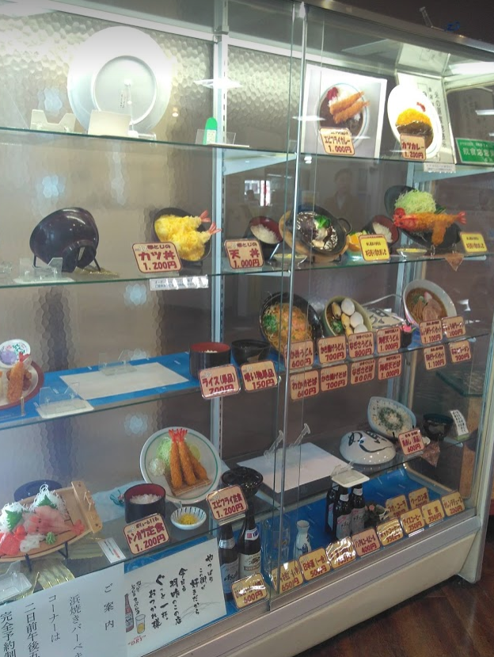　4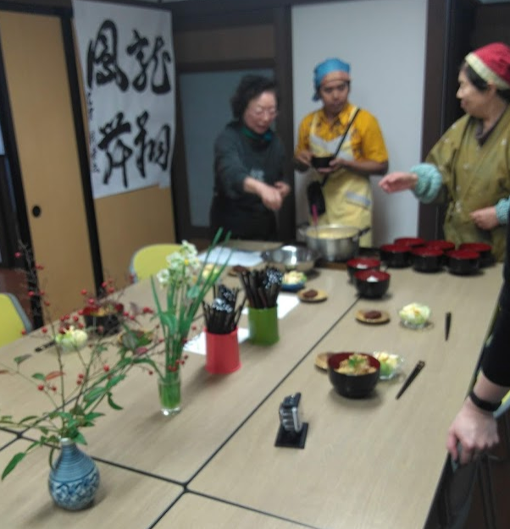

．．

|  |  |  |  |  |  |  |
| --- | --- | --- | --- | --- | --- | --- |
| **１ﾁ** | **ｰ** | **ｽﾞ** |  |  |  |  |
| **ョ** |  |  |  |  |  |  |
| **ｺ** |  |  |  |  |  |  |
| **２ﾚ** | **ｰ** | **ｽﾞ** | **ﾝ** |  |  | **３ﾌﾟ** |
| **ｰ** |  |  | **２ﾊﾞ** |  |  | **ﾗ** |
| **ﾄ** |  | **3ﾚ** | **ｽ** | **ﾄ** | **ﾗ** | **ﾝ** |
|  |  | **ｼ** |  |  |  |  |
|  | **4ﾃ** | **ｰ** | **ﾌﾞ** | **ﾙ** |  |  |
|  |  | **ﾄ** |  |  |  |  |

たて

1．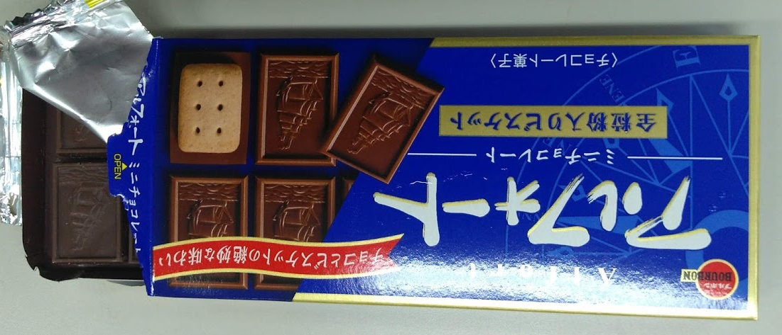　　２．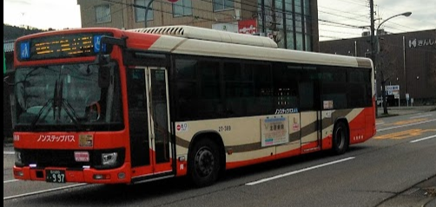　３．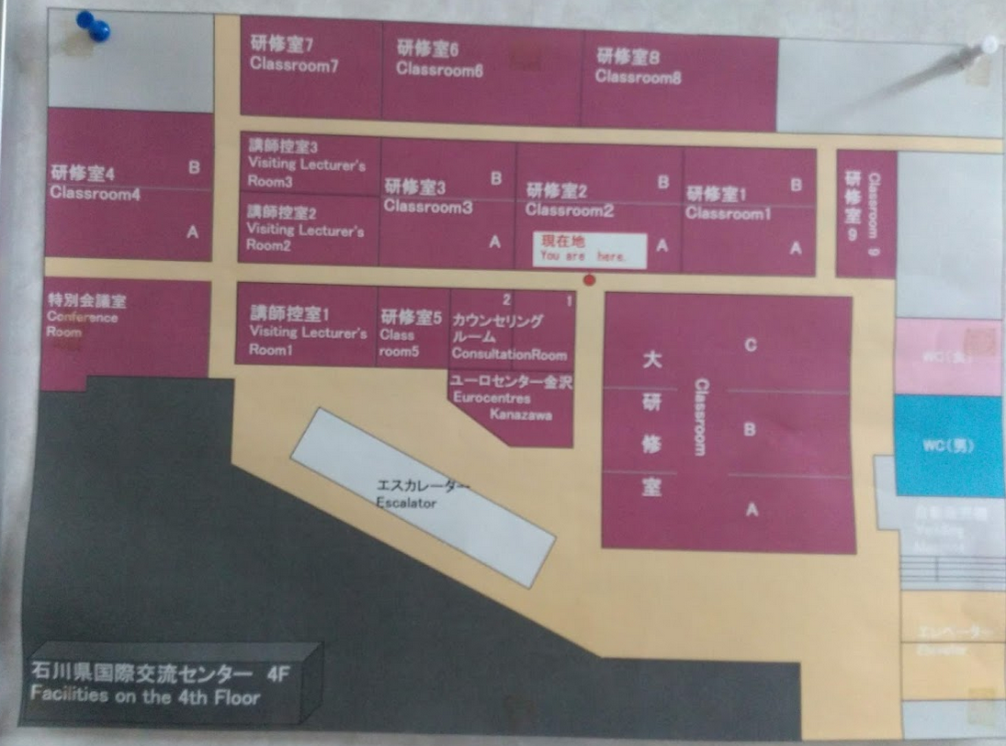　４．