**クロスワード**

よこ

１．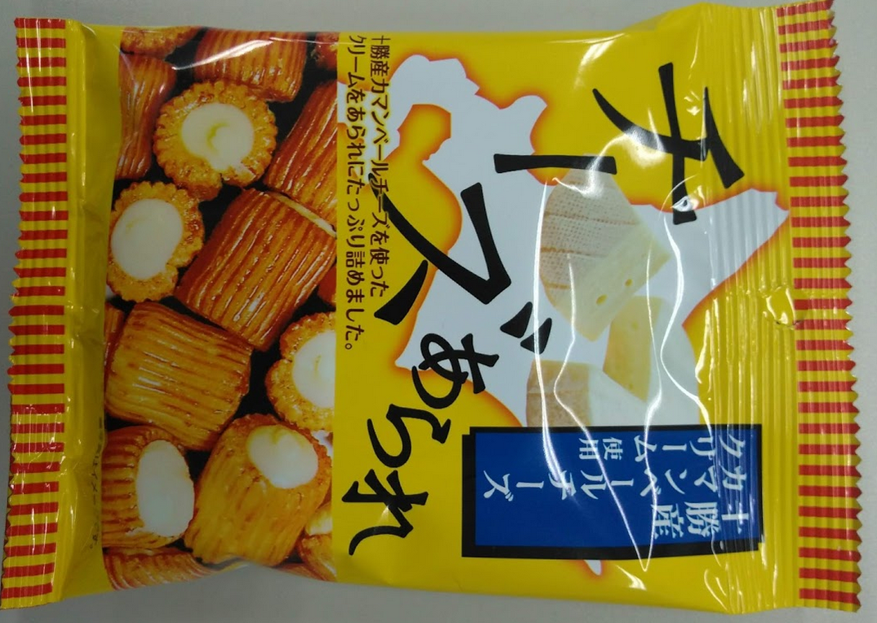2．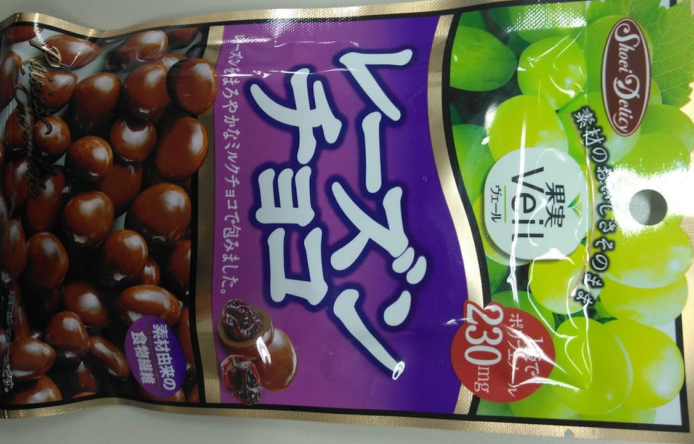3．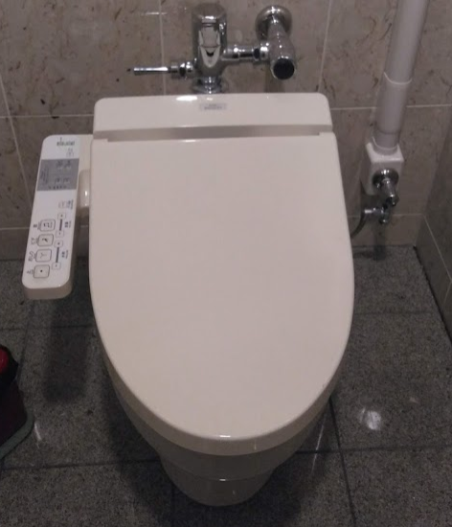

3．　４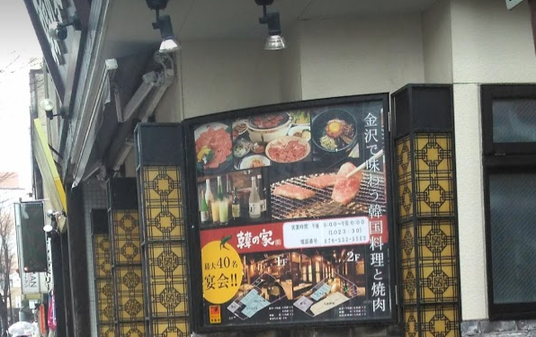　５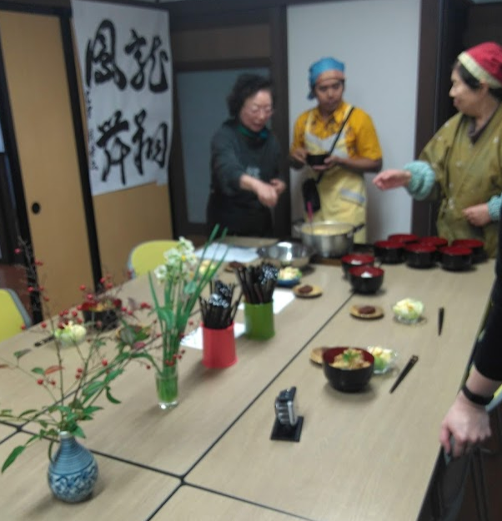

．．

|  |  |  |  |  |  |  |
| --- | --- | --- | --- | --- | --- | --- |
| **１** |  |  |  |  |  |  |
|  |  |  |  |  |  |  |
|  |  |  |  |  |  |  |
| **２** |  |  |  |  |  | **３** |
|  |  |  | **２** |  |  |  |
| **３** |  | **４** |  |  |  |  |
|  |  |  |  |  |  |  |
|  | **５** |  |  |  |  |  |
|  |  |  |  |  |  |  |

たて

1．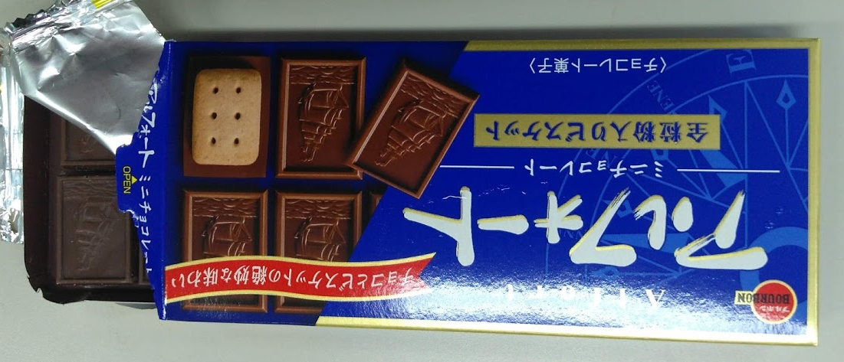　　２．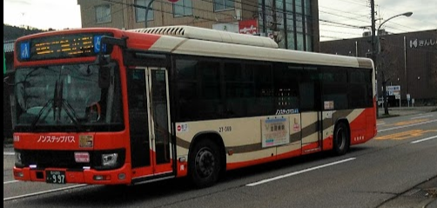　３．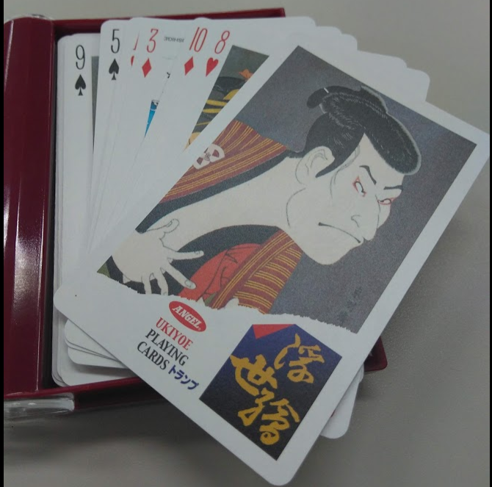　４．